1. Install nginx and run nginx on port number 81.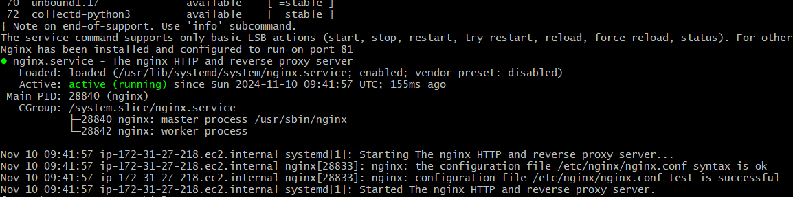
2. Deploy a sample index.html file on nginx.

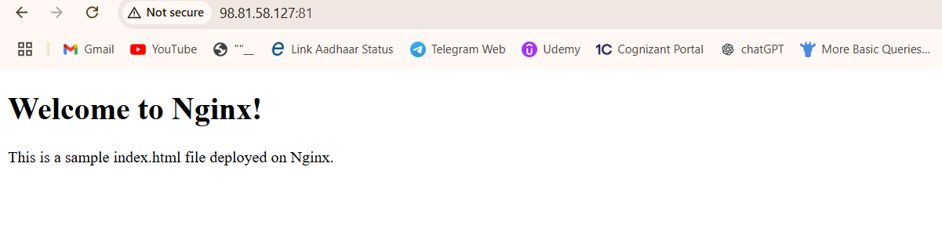

3) Install Apache and run Apache on port number 82

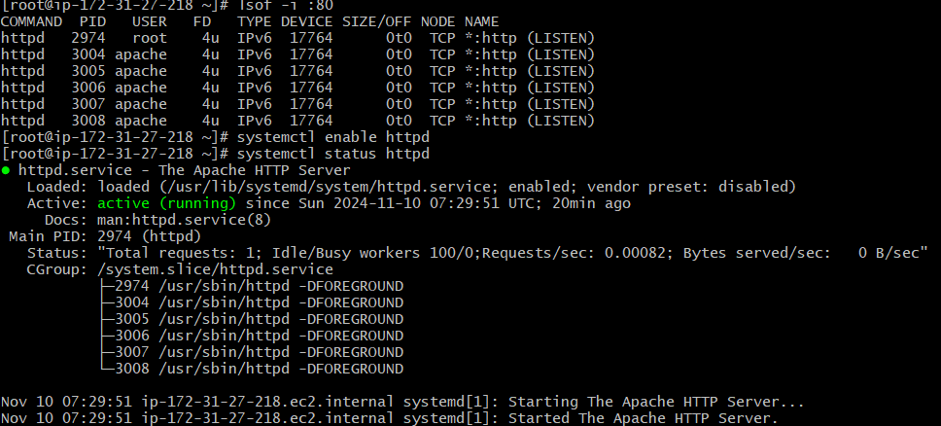



4) Deploy a sample index.html file on Apache.

5) Install Apache tomcat on port number 8082

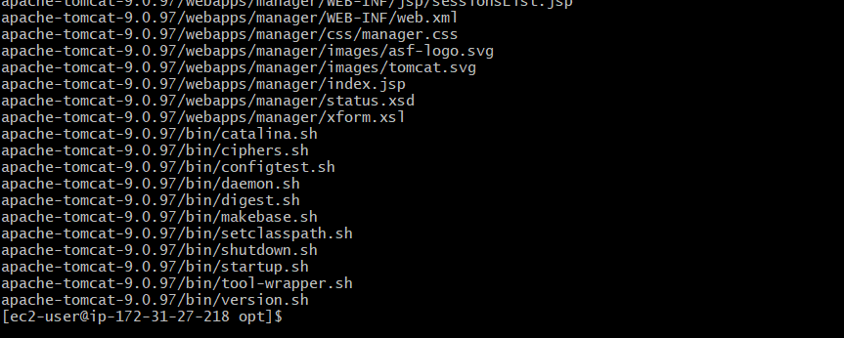

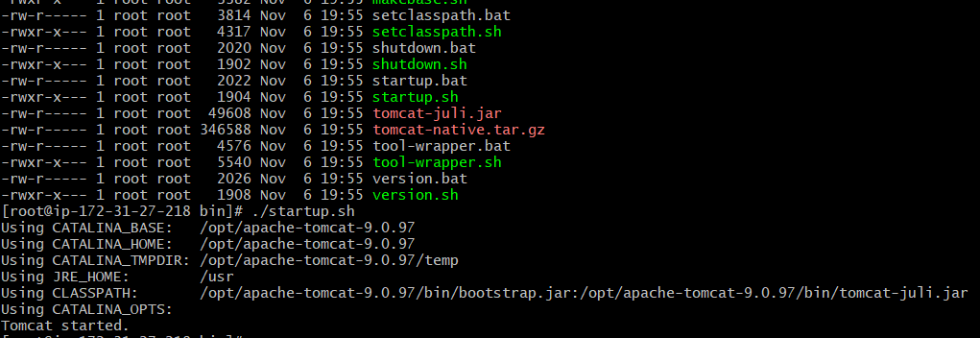

6) Deploy a sample app on webapps

